Financial Accounting

FI 1: Display Chart of Accounts

Submit the above completed table (5 points)

|  |  |
| --- | --- |
| G/L Account Number | G/L Account Name |
| 100000 | Bank Account |
| 200100 | Inventory-Finished Goods |
| 300000 | Payables-Trade Accounts |
| 310000 | Goods Receipt / Invoice Receipt Account |
| 600000 | Sales Revenue |
| 700000 | Labor Expense |
| 720300 | Semi-Finished Consumption Expense |
| 740300 | Rent Expense |
| 741500 | Utilities (electricity & phone) Expense |
| 770000 | Research and Development |

FI 2: Display Chart of Accounts II

Submit answers to the following questions:  
How does this information differ from the information in Exercise FI 1? What are the company codes this chart of accounts is assigned to? (5 points)

The previous exercise shows all the charts of accounts for Global Bike. They just provides the complete list of charts of account and account names. Whereas, in the current steps, this provides all the information about the chart of account ie G/L account and their associated company code (DE00 and US00) and other related details for each G/L Account.

This chart of account is assigned to 2 company code:

1. DE00 – Global Bike Germany GmbH
2. US00 – Global Bike Inc.

FI 3: Display General Ledger Account

Submit answers to the following questions (10 points)

What Account Group is this G/L account assigned to?

LA Liquid Assets

Is this account a Profit and Loss Statement account or a Balance Sheet account?

Balance Sheet account

What is the account currency?

United States Dollar

Repeat the same procedure for the same G/L account, but for the German Global Bike Company Code (**DE00**).

What differences did you find?

The account currency changed to European Euro.

FI 4: Review Reconciliation Account

Submit a screen shot of the Customer Line Item Display Screen (2.5 points)

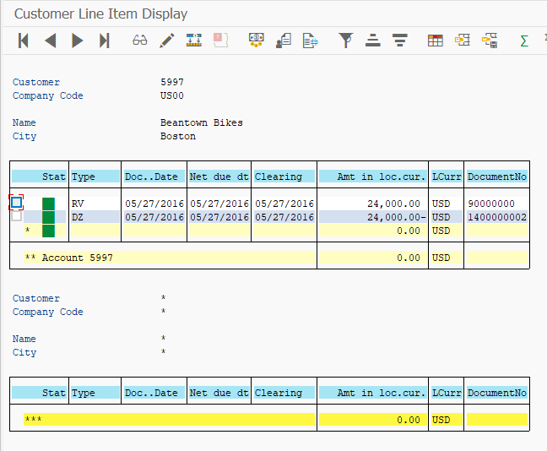

Submit a screen shot of G/L Account Line Item Display G/L View (2.5 points)

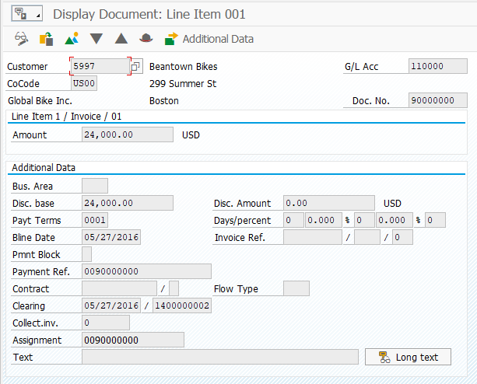

Submit a screen shot of Display Document: Data Entry View (2.5 points)

